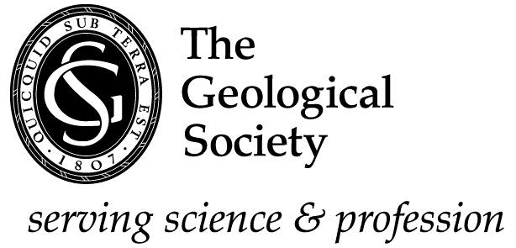 | 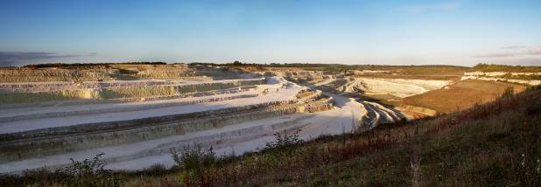
Home Counties North Regional Group

Virtual Palaeontology

Mark Sutton
Virtual palaeontology is a powerful (revolutionary?) new approach to the study of fossils, which opens new possibilities for computational palaeobiological analysis, recovery of difficult material and dissemination of morphological data. A broad group of techniques are suitable for nearly all fossils and virtual palaeontology will be a mainstay of palaeontology for the 21st century.
It entails the study of 3-dimensional (3-D) fossils on screen as digital interactive screen models. Reconstruction is directly from single real specimens as a medium for palaeobiological study. It requires 3-D fossils, which are not uncommon and even 3-D soft parts are not too rare.

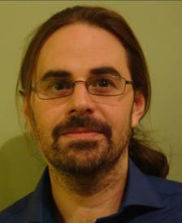
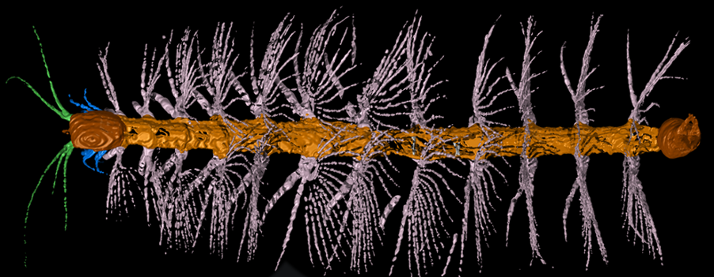

Mark Sutton did a degree in Natural Sciences at Cambridge, specialising in Geology and Palaeontology. then did a PhD in Cardiff, in Welsh Ordovician Inarticulate Brachiopods, followed by a 3-year stint in Lampeter (darkest Wales) lecturing in IT. In 1999 he started 6 years in Oxford, working on the 3-D fossils of the Herefordshire Lagerstatte, where he became interested in 3-D reconstruction and virtual palaeontology. Since 2005 he has been a lecturer at Imperial College, researching a range of palaeontological subjects centred around the origin and early evolution of major invertebrate groups, often using virtual techniques.

Date: Thursday 19 November 2015
Venue: Sir Robert McAlpine, Eaton court, Maylands Avenue, Hemel Hempstead HP2 7TR
Refreshments 18.00
Meeting starts 18.30
For more information on the Home Counties North Regional Group visit the website at http://www.geolsoc.org.uk/hcnrg


